Assignment 7 – OO Design/Programming
Geometry: intersection, Exercises 9.10, 9.9
Suppose two line segments intersect. The two endpoints for the first line segment are (x1, y1) and (x2, y2) and for the second line segment are (x3, y3) and (x4, y4). Write a program that reads the four endpoints from a file, coords.txt, and displays the intersection point if it exists. Use the LinearEquation class in Exercise 9.9 for finding the intersection point.

Exercise 9.9 (Algebra: 2x2 linear equations)
Design a class named LinearEquation for a 2x2 system of linear equations:

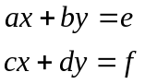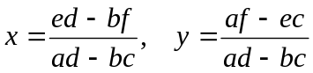

The class contains:
- Private data fields a, b, c, d, e, and f.
- A constructor with the arguments a, b, c, d, e, and f.
- Six get functions for a, b, c, d, e, and f.
- A function named isSolvable() that returns true if 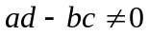.
- Functions getX() and getY() that return the solution for the equation.

Note If 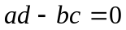, the equation has no solution and the corresponding lines do not intersect (are parallel).

Instructions
- Also see Exercises 3.3, 3.22
- Test your code by reading the data from the given file coords.txt. Each line of the file contains 8 real numbers representing (x1, y1), (x2, y2), (x3, y3), (x4, y4), respectively.
- Display the result to the console.

